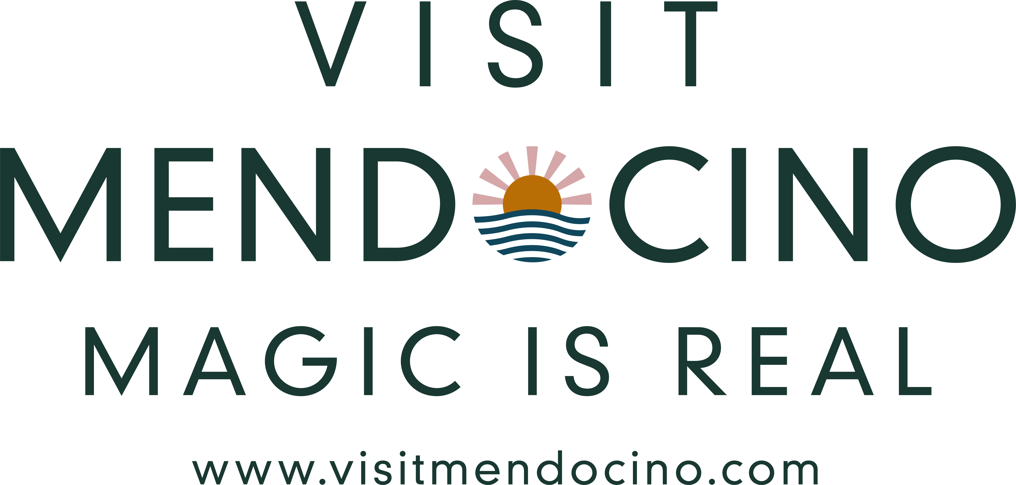

**CONTACT:**

Koleen Hamblin; 805.451.2015

Link2koli@gmail.com

Jamie Peters-Connolly; 707.964.9010

jamie@visitmendocino.com

***MADE IN MENDOCINO***

***FROM VELVET SISTER TO CALI BIRRA AND FRENCH HIDCOTE, A TREK THROUGH***

***MENDOCINO COUNTY’S FARMS IS A STUDY IN SUSTAINABILITY, SPARKING ALL THE SENSES***

***A Taste of Place from Resource-full Mendocino County***

**MENDOCINO COUNTY, CALIF.** – In the land of smoked seaweed and Piment d’Ville lies a cache of chefs, farmers and culinary artisans who have long pushed the edible envelope. From the early 1960s when Mendocino County became a magnet for creatives celebrating the back to the land movement, the art of farming has evolved into a wealth of local products that speak to the region’s unique terroir. Honey, yak, whiskey, farmstead cheese, hard cider, florals and cannabis farmers have put their stamp on made in Mendocino. Add in 12 diverse AVAs, 90 miles of prime Pacific Coastline and enough oxygen-rich redwood forests to reboot the brain, and a visit to Northern California’s crown jewel delivers a delicious slice of “straight from the source.” [www.visitmendocino.com/farm-treks-in-mendocino-county](http://www.visitmendocino.com/farm-treks-in-mendocino-county).

**FORK IN HAND – TOP TREKS FOR FOODIES ON THE FAST TRACK**

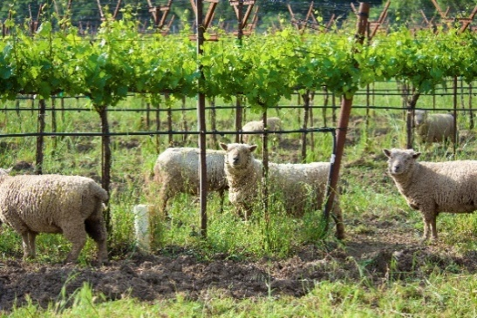**PENNYROYAL FARM**

Start at Pennyroyal Farm, a polished venue marking the entrance to wine-centric Anderson Valley. Morning tours of the award-winning farmstead creamery include a walk-through of the solar-powered barn to meet the animals – 150+ dairy goat companions and 40+ dairy sheep and a sheep grazing flock of 200+ ewes on fun, full display.

Visitors can learn about the integrative methods behind both the estate wines and cheeses from cutting and molding of curds, through the aging stage and final packaging. The cheeses are named in Boontling, a unique language that originated in Boonville and the surrounding hills at the end of the 19th century, and are a mix of goat and sheep milk. Names like Velvet Sister, Boont Corners and Bollie’s Mollies round out the selection. A final cheese and wine tasting rounds out the tour, including the winery’s signature Sauvignon Blanc. [www.pennyroyalfarm.com](http://www.pennyroyalfarm.com).

**EARTHSPOKE FARMS**

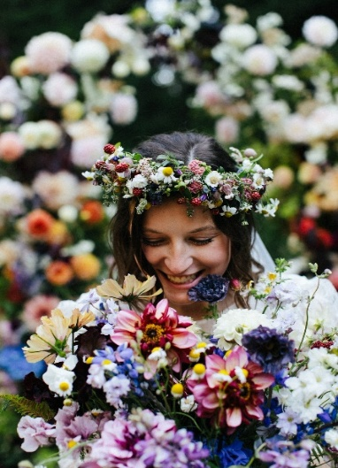 It’s the definition of flower power, Mendo-style. Located just south of Point Cabrillo Lighthouse on scenic Highway 1 lies Earthspoke Farms, an ethereal escape boasting expansive fields of more than 5,000 dahlia plants and hundreds of colorful annuals and perennials as far as the eye can see. The 10-acre farm specializes in curating and growing more than 200 dahlia cultivars using regenerative, sustainable farming practices. From U-Pick Flower Field Days to a DIY Bouquet Bar and a seasonal pumpkin patch, this is the stop for enthusiasts seeking a robust reboot with Mother Nature. [www.earthspokefarms.com](http://www.earthspokefarms.com).

**BOONVILLE BARN COLLECTIVE**

From Sugar Rush to Piment d’Ville, a Mendocino version of the Basque spice Piment d’Espelette, a walkabout through the Boonville Barn Collective is a study in raising the bar on chiles, one plant at a time. One of the few farms in California to produce dried chiles at scale, the Collective is a woman-owned operation straddling four acres in the small enclave of Boonville. From seed to jar, the small-batch production includes a variety of spices including Sugar Rush, Cali Birra and Yahuaclica Chile de Arbol. Olive oil, sea salt and a variety of heirloom beans, including Tiger’s Eye, Zolfini and Tolosa are grown on property. Tours are by appointment only, pack the boots and tie in a wine tasting nearby at Lichen Estate. [www.boonvillebarn.com](http://www.boonvillebarn.com).

**TERRA SAVIA**

Art, wine and olive oil in the great outback, what’s not to like? Tap into a sunny day of play in Mendocino’s interior region via Terra Savia. Set on 64 acres – 35 of it planted to vineyards – the Hopland-based estate is a working farm and olive mill making for an ideal stop for tasting in the rustic mill. The Old-World feel combines meandering goats, sheep, resident owls, a native plant nursery, vegetable gardens and a bold revolving art collection. It’s easy to while away a few hours on a picnic by the pond or taste the region’s top olive oils in one simple step. [www.terrasavia.com](http://www.terrasavia.com).

**GOWAN’S CIDER GARDEN & FARM**

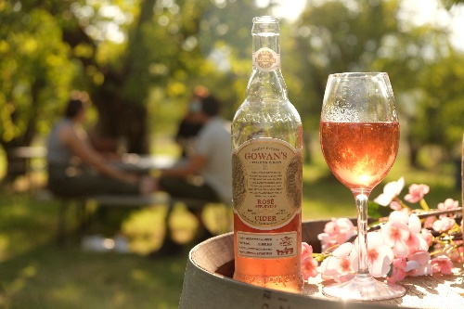Book a table under the 130-year-old Red Gravenstein and sip away in a classic California apple grove. Set on Highway 128 in Philo, pull in for a fragrant slow-down in an eye-popping living outdoor museum. Gowan's world-class ciders are made onsite with organic heirloom apples sourced exclusively from the Gowan estate heritage orchards. Established in 1876, this sustainable family farm spans six generations and nearly 150 years. Depending upon the time of year, blossom bathing may be an option under the flowering trees as well as sampling eight different award-winning ciders, paired with bites. [www.gowansheirloomcider.com](http://www.gowansheirloomcider.com).

**PETIT TETON FARM**

Sometimes a pop in to a real working farm is a reality check on where one’s dinner really comes from. Check that box at Petit Teton Farm, set in scenic Yorkville along Highway 128. For 20+ years, Nikki Ausschnitt and Steve Krieg have worked the land growing a wide range of fruits, vegetables, ducks, rabbits, yaks and pigs, selling various types of meat and eggs in their quaint mountain setting. The small kitchen turns out preserves for sale and is open daily. The sharp drive up the hill delivers views of old California with animals grazing and gardens in bloom. Pack home some jams and help support small farmers. [www.petiteteton.com](http://www.petiteteton.com).

**MENDOCINO LAVENDER & POLLINATOR GARDEN**

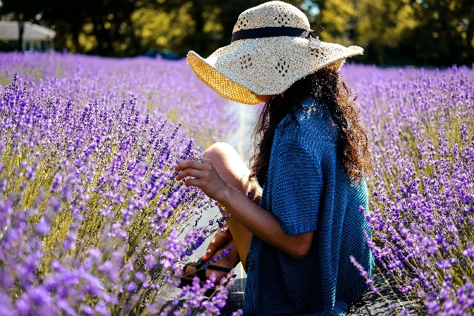Sniff some lavender, swirl some wine.  Set in Anderson Valley, one of Mendocino’s top wine growing regions, this new 2.5-acre lavender farm shares space with Foursight Winery, a small family-owned operation crafting premium Pinot Noir and Sauvignon Blanc.  Guests can tour the fields, which encompass six varieties including French Hidcote, Grosso, Provence and specialty strains that bloom white, pink and magenta, and an extensive native plant collection, or combine a wine/lavender duo for the ultimate olfactory sensation.  The 15-acre estate marking the entrance to Boonville is a perfect prelude to a day of play with some 25+ wineries dotting the 15-mile stretch to the sea.  Lavender products are available for sale as well as estate wines.  Peak bloom season is June through August. <https://mendocino-lavender.com/>.

**EMERALD FARMS CANNABIS TOUR**

Visitor forecast: 100 percent chance of getting a buzz!  Just as wine turned California into a tourism hotspot, legal cannabis has become a mainstream tourism niche for the state, especially the renowned Emerald Triangle which is legendary for producing the world's best stash.  Mendocino’s legacy farms are a testament to the commitment growers have made over multiple generations and now visitors can get an inside peek behind the "Emerald Curtain." The tour starts at Black Oak Coffee Roasters in Ukiah; from there, it’s onto the lush and storied Redwood Valley for a hands-on, fun and educational 4-hour trek which includes a farmer-led walking tour of a regenerative cannabis farm and onsite hash-making demonstration, followed by a tuck into a local dispensary and consumption lounge for a full farm-to-bud experience.  $249/person; [www.emeraldfarmtours.com](http://www.emeraldfarmtours.com).

**SCHNAUBELT DISTILLERY**

From Smoked Salmon Vodka to a Candy Cap Mushroom Bourbon, Schnaubelt Distillery is the stop for a spirited tour de force of Mendocino’s top crop of rum, gin, whiskey and vodka.  Set in rustic Noyo Harbor, a working harbor flush with seafood shacks, uni hauls and family-fun boat tours in Fort Bragg, visitors can hit it straight to the source with a self-tour and tasting of the working distillery.  Opened in 2023, Schnaubelt offers an inside peek of the operation behind crafting some truly unique spirits with an eye-catching collection of varied copper stills working the day and night shift.  Tastings include a full lineup of six spirits, and a full cocktail menu is available onsite. [www.schnaubeltdistillery.com](http://www.schnaubeltdistillery.com/)

**BACKGROUND**

Mendocino County welcomes nearly 1.8 million visitors annually who explore its 90 miles of prime Pacific coastline, 90+ wineries and 12 diverse AVAs (earning the highest percentage of organic and biodynamic vineyards in the United States), 24 state/national parklands and 450+ unique accommodations. Straddling scenic Highways 1 and 101, “The Redwood Corridor,” the County delivers an ideal vortex of waves, wines and redwoods laced with historic villages and outback adventures. Located 114 mi./184 km. north of San Francisco, the region’s gateway airports are San Francisco International (SFO), Oakland International (OAK), Sacramento International Airport (SMF), and Charles M. Schulz-Sonoma County Airport (STS). Visit Mendocino County is a non-profit destination marketing organization designed to enhance the economic vitality of the community by increasing tourism revenue. For more information, go to www.visitmendocino.com.

# # #

 VisitMendocinoCounty

https://encrypted-tbn2.gstatic.com/images?q=tbn:ANd9GcQmN4Hz1m2z4hoqhQtyywvPl7GkxDHUNt9OJDZZvBN7_uNmBZFw @VisitMendocino

Instagram logo 2016.svg @VisitMendocino

2/2025