**THE SPANISH TOURIST OFFICE ANNOUNCES WINNERS OF SPAIN’S SUSTAINABLE MEDIA AWARDS**

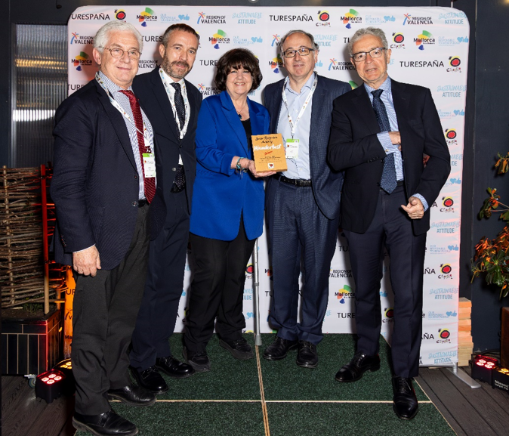

**Please find imagery of the event** [**here**](https://socialnewsroom.spain.info/spain-sustainability-day-image-gallery-2024/)**.**

**London, 18 April 2024 -** The Spanish Tourist Office (UK) has revealed the winners for Spain’s Sustainable Media Awards, announced at a ceremony at The Conduit, London, on Wednesday 17 April 2024, following Spain’s Sustainability Summit, which featured important discussion and debate on key issues relating to the travel industry and sustainability.

The awards opened by the Spanish Ambassador to the United Kingdom, Mr José Pascual Marco Martínez and hosted by Manuel Butler, director of the Spanish Tourist Office, recognised the best travel content by UK writers showcasing themes which correspond to Spain’s sustainable tourism pillars, such as seasonal or geographic diversification, forming a connection with local people and cultures, visiting lesser visited areas and taking part in low-impact activities.

Prior to the media awards, a ‘**Special Recognition Award’** was presented by Lyn Hughes, founding editor of Wanderlust Magazine and Miguel Sanz, director of Turespaña, to Luis Gallego Martín, CEO of International Airlines Group (IAG), for his part in creating the roadmap to becoming the first global airline group to commit to becoming net zero by 2050 and the first European airline group to set the target of 10% Sustainable Aviation Fuel by 2030.

The winners and runner-up for each category in Spain’s Sustainable Media Awards 2024 are as follows:

**Sustainable Content Creator Content of the Year**

**WINNER: Simon Parker -** The Guide to Cycling in Mallorca: Exploring Beaches, Coves, and Mountains | Times Travel **(The Times YouTube)**

**RUNNER-UP: Joanna Nemes -** Everything You Need to Know About Visiting the Cordoba Patio Festival – Fiesta de Los Patios (**Andalucia in My Pocket**)

**Trade Tourism Feature of the Year (Print/Online)**  
**WINNER: Charlotte Cullinan -** How an Iberostar Majorca fam showcased the impact of sustainability (**TTG**)

**RUNNER-UP: Robin Murray -** An e-bike tour shows the Spanish city’s less-visited natural side, finds Robin Murray (**Travel Weekly)**

**Online Consumer Sustainable Tourism Feature of the Year**

**WINNER: Emma-Louise Pritchard -** I chose a 33-hour ferry over a 2-hour flight to Spain for a slow trip all about nature (**Country Living**)

**RUNNER-UP: Meera Dattani -** What a slow trip to northern Spain really looks like (**Wanderlust**)

**Consumer Magazine Sustainable Tourism Feature of the Year (print)**

**WINNER: Stephen Phelan -** Hike the Highlands (**National Geographic Traveller**)

**JOINT RUNNER-UP: Ross Clarke -** Myths, monoliths and markets: JRNY Magazine (**JRNY Magazine**)  
**JOINT RUNNER-UP: Marti Buckley -** Hidden Spain: Tiny wine regions (**Decanter**)

**Consumer National Newspaper Sustainable Tourism Feature of the Year (print)**

**WINNER: Chris Haslam -** I made the pilgrimage to Santiago de Compostela by rail. This is why (**The Times**)

**RUNNER-UP: Sarah Gordon** - The exhilarating road trip around Spain’s most underrated region (**The Times)**

The judges of Spain’s Sustainable Awards were Carol Rose, Head of Sustainability at ABTA, Thomas Power, CEO of [Pura Aventura,](https://pura-aventura.com/) Richard Hammond, Founder of [Green Traveller,](https://www.greentraveller.co.uk/) Zina Bencheikh, Managing Director of [Intrepid Travel,](https://www.intrepidtravel.com/uk) Manuel Butler, Director of [The Spanish Tourist Office in the UK](https://socialnewsroom.spain.info/spain-sustainability-media-awards/)

Manuel Butler, director of the Spanish Tourist Office says:

“Sustainable travel is at the heart of our strategy here at the Spanish Tourist Office and we are delighted to see the variety and quality of the pieces submitted for our inaugural media awards. I would like to congratulate everyone that made the shortlist, and we thank the UK media for illustrating such important topics. I’d also like to congratulate Luis Gallego Martín from IAG for initiating such important progress within the aviation sector”.

-**Ends**-

For more information on Spain as a tourism destination, please visit [www.spain.info](http://www.spain.info/)

[@Spain_inUK](https://twitter.com/spain_inuk?lang=en)  / Spain on [Facebook](https://www.facebook.com/spain.info.gb/?brand_redir=184786328961) or email [spain@wearelotus.co.uk](mailto:spain@wearelotus.co.uk)

**#SpainSustainabilityDay**