

**CONTACT:**

Koleen Hamblin; 805.451.2015

Link2koli@gmail.com

Jamie Peters-Connolly; 707.964.9010

jamie@visitmendocino.com

**DARK SKY TOURISM**

***THE ULTIMATE ASTRAL AFFAIR AWAITS IN MENDOCINO COUNTY WITH LIGHTHOUSE TOURS,***

***RANGER-LED REDWOOD ROMPS AND THE ANNUAL PERSEIDS METEOR SHOWER CAMP-OUT***

***-Pack the Binoculars, a Bottle of Mendocino Bubbly and Blast Off-***

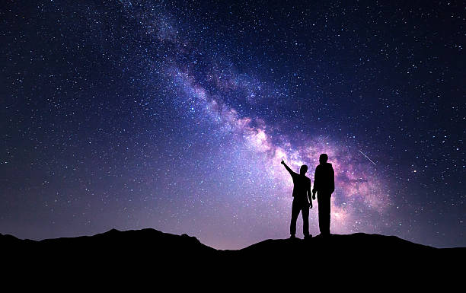**MENDOCINO COUNTY, CALIF.** – There’s a new trend in tourism that is taking rural regions by storm: Dark Sky Tourism. According to *National Geographic*, unplugging under the stars in destinations light on light pollution is gaining in popularity with new hotel programs, weekend astrological camp-outs and park ranger-led constellation cavorts taking center stage. Mendocino County, Northern California’s crown jewel with 24 state and national parks and a wealth of inns and enclaves unscathed by urban light, is a top choice for travelers seeking pristine starry nights and a front row seat to the 11-year Solar Maximum cycle. www.visitmendocino.com/dark-skies-in-mendocino-county/

**STAR POWER**

From views of Jupiter and its moons to the upcoming Perseids Meteor Shower and beyond, stargazing can add another element to the seasonal camp trip or fall scout around the coast of California. Time the trip right and a wealth of evening activity is both free and fascinating. Ideal dates are around the new moon phases when the sky is the darkest. Essentials such as a pair of binoculars, a simple star chart or application and red flashlight (to preserve night vision) are all that’s required. Once the sun sizzles, a celestial phenomenon is certain to wow!

The timing couldn’t be more perfect: the world is currently at the peak of Solar Cycle 25, an 11-year cycle that is expected to deliver high levels of solar activity. Predictions from the World Data Center for the Sunspot Index and Long-term Solar Observations (SILSO) at the Royal Observatory of Belgium indicate a maximum between mid-2024 and the end of 2025. Meanwhile, NOAA's Space Weather Prediction Center (SWPC) estimates that solar maximum could occur between late 2024 and early 2026.  This translates into a wealth of opportunities for travelers looking to tap into an astral adventure.

**TOURS, TENT-OUTS & TINY WONDERS**

A celestial rendezvous is easy and affordable. At Mendocino County’s **Hendy Woods State Park**, tucked deep with the wine-centric Anderson Valley, rangers get up close and personal with the seasonal constellations via night sky adventures from June 20 through August 15. Star clusters, galaxies, nebula and a never-ending parade of planets are on tap every Thursday evening from 9:00 p.m. to 10:00 p.m. www.parks.ca.gov/EventDetails/15987.

For those seeking a larger wow factor, the **8th Annual Perseids Meteor Shower Campout at Mendocino Magic** is the ticket. Set for August 9-11, 2024, when the shower reaches its peak with shooting stars, brilliant light tails and an ongoing array of eye candy, campers can snag a spot and capture the celestial event on a mountaintop nicknamed **Methuselah’s Observatory**. One of the year’s favorite events, The Perseids Meteor Shower is caused by Comet 109P/Swift-Tuttle, which takes 133 years to orbit the sun.  In clear skies, the shower can produce around 100 visible "shooting stars" per hour with the best time to see the most meteors being just before dawn.  www.mendocinomagic.com/perseids.

For groups seeking a private outing backed with star power, **Night Sky Adventure** offers a variety of celestial gazing programs specializing in observations of the moon and planets, as well as deep space objects. Pick the spot and the team will organize an outing complete with telescope systems and expert astronomers. www.nightskyadventure.com.

On the scenic California coast, **Point Arena Lighthouse** – originally built in 1870 – offers seasonal night tours certain to make any astral enthusiast swoon. Tap into the (almost) Full Sturgeon Moon Tour (August 17); (almost) Full Harvest Moon Tour (September 14); (almost) Full Hunter’s Moon Tour (October 19) or (almost) Full Beaver Moon Tour (November 16); www.pointarenalighthouse.com/visit.

Enthusiasts seeking a perch with a bit more comfort can check into the 65-room **Little River Inn** and check out the night sky via the **Stargazing Package**. Bed down with a two-night stay, use of binoculars, a star guide, travel blanket, hot chocolate and Comet Corn to round out the evening. From complimentary blankets and binoculars at **Sea Rock Inn** to the Star Bathing experience at **Mar Vista Farm + Cottages**, Mendocino County’s natural high can’t be beat! www.littleriverinn.com/stargazing-package/; www.searock.com; www.marvistafarmandcottages.com/wellness/.

**THE ULTIMATE ASTRAL AFFAIR MENDO-STYLE**

With solar activity at its highest this year into next, now is the ideal time to tap into a dark sky adventure Mendo-style. With plenty of wide-open spaces, the options for booking a remote cabin in the redwoods, shoreline inn or top camp spot sporting a world view are plentiful. For those who enjoy camping with the giants, snag a site at Navarro River Redwoods State Park, fronting a meandering river, or on a more rustic note, **Jackson Demonstration State Forest**, just inland from Fort Bragg. Here the heavily forested area provides darker skies and a closer connection to the cosmos. On the Pacific Coast, **Point Arena-Stornetta Public Lands** offer stunning views with the added plus of tapping into the nearby lighthouse for seasonal tours. www.visitmendocino.com/4-magical-spots-to-explore-the-redwoods-in-mendocino-county/.

**BACKGROUND**

Mendocino County welcomes nearly 1.8 million visitors annually who explore its 90 miles of prime Pacific coastline, 90+ wineries and 12 diverse AVAs (earning the highest percentage of organic and biodynamic vineyards in the United States), 24 state/national parklands and 450+ unique accommodations. Straddling scenic Highways 1 and 101, “The Redwood Corridor,” the County delivers an ideal vortex of waves, wines and redwoods laced with historic villages and outback adventures. Located 114 mi./184 km. north of San Francisco, the region’s gateway airports are San Francisco International (SFO), Oakland International (OAK), Sacramento International Airport (SMF), and Charles M. Schulz-Sonoma County Airport (STS). Visit Mendocino County is a non-profit destination marketing organization designed to enhance the economic vitality of the community by increasing tourism revenue. For more information, go to www.visitmendocino.com.

# # #

 VisitMendocinoCounty

Instagram logo 2016.svg @VisitMendocino

7/2024